Decision Making and Problem Solving 2019-20 Tri 2- Andre Samuel
PART 2: INDIVIDUAL WRITTEN ASSIGNMENT 2,400 WORDS, 80% OF MODULE ASSESSMENT

Q1 With reference to a listed company of your choice identify a recent major issue that they have had to deal with. Describe what the issue was and discuss how your chosen company dealt with it.
20%

1.0 Introduction to Problem Solving

Introduction to problem solving- basic definitions
Introduce the chosen company

Organization Background
Basic insights into the company
Introduction the Problem/issue faced

1.2 Problem Definition

1.2.1 Give context of problem (use evidence- organizational data, external data) apply strategic tools where necessary such PEST, Five Forces, Financial Performance etc. This will depend on the chosen Issue.

1.2.2 Justification of chosen Problem- discuss the strategic importance of solving the problem, state the type of problems (theory- unstructured, semi-structured, structured etc).

1.3 Decision Taken and Approach Used

Given the problem/issue discussed above what was the decision taken by the company? State clearly.

Briefly discuss the nature of the decision. What approach the company use to make the decision- Logic/rational, Mind Games/intuition??? Support your discussion of the approach with relevant literature.

ARU Guidance: Students should be justifying their choice of problem, not just describing the problem, supported with justification from organisational data. The justification should include introductory theory on problem solving to support why the student selected this decision. The student should describe the approach to decision making and problem solving taking by the organisation, not just the solution reached.

Q2 Critically appraise the approaches used by the organisation in trying to address this major issue. With hindsight and time suggest how the company could have responded better. What other decision making and problem solving techniques would have been most appropriate for this decision or problem
50%

2.0 Analysis of Decision Making Approach

Introduction – discuss problem solving models, i.e. Steps e.g. Simon Stages, Adair, McKinsey

Based on the models discussed, give outline of themes for the analysis

2.1 Intelligence

2.2 Design

2.3 Choice
For EACH of the above stage:
- Discuss what this stage involves (use theory)
- How did the company go about this stage?
- What decision making techniques were used during the stage e.g. brainstorming, use of consultants, lateral thinking, etc.?
- You can apply relevant techniques to the decision e.g. force field analysis, decision tree, weighted analysis, six hats etc.
- Compare the company’s practice to relevant theory
- Recommend additional techniques that should have been used by the company for the stage, use theory to support. E.g. Proctor (2009) suggest that lateral thinking is appropriate for complex problems………………
- Apply the Recommended techniques using a scenario. E.g. Decision making tree, weighted analysis, force field analysis.
2.4 Summary of Evaluation
Here you are giving and overall picture of the Decision Making Process used by the company, essentially, summarising the above evaluation. Could use a well-known checklist or Model and give each stage a score/rating of how well it was done.
The following table could be useful as well
Stages | Approaches Used by Organization | Key weakness | Recommended techniques | Overall Score (1-5)
Intelligence | List techniques used by company | - Inappropriateness of Techniques  - Factors not considered not considered  - Etc. | List recommended techniques

Design

Choice
ARU Guidance: Good answers here will be supporting their evaluation with theory, and providing other options and arguing the optimal way of tackling this problem or decision. Students should support their proposed options with evidence from theory, and potentially other contemporary companies’ successes and failures.

Q3 As the company is listed on the stock market analyse how that market viewed the major issue and the company’s responses that followed. This will involve analysing the company’s share price across the period of the event.

Implementation theory to be discussed here, in context of the particular organisation and problem. You should demonstrate a clear knowledge of available implementation methods and how they relate specifically to this particular decision or problem.
20%

3.0 Market Reaction

This requires an analysis of the Business Performance and Market Reaction of the decision, essentially providing a before and after look.

3.1 Impact on Shareholder Value
Use any Industry Specific KPI’s including: Profit Margin, Sales, Share Price, market cap and volume of shares traded can be used. Other indicators of Stock market performance can be used as well.

Need to discuss the impact of the problem/decision on the various KPI’s and give figures before and after the decision

Example: when Samsung decided to Recall all Galaxy Note 7 due to exploding batteries, their mobile division profit fell by 96%, company’s Operating profit fell by 30% and the halt in production and sales resulted in a 9.5B loss in mobile revenue. Its stock plummeted 8% in Seoul, wiping about $17 billion off the company's market value. CNNTech (2016).

Useful table:
KPI’s | Before Decision 2016 | After Decision 2017
Financial Performance  - Profit Margin  - Sales Growth | 32%  11% | 25%  4%
Stock Market
- Share price
- Market Cap

This can then be used to build some charts to visually show the reaction.

Example:

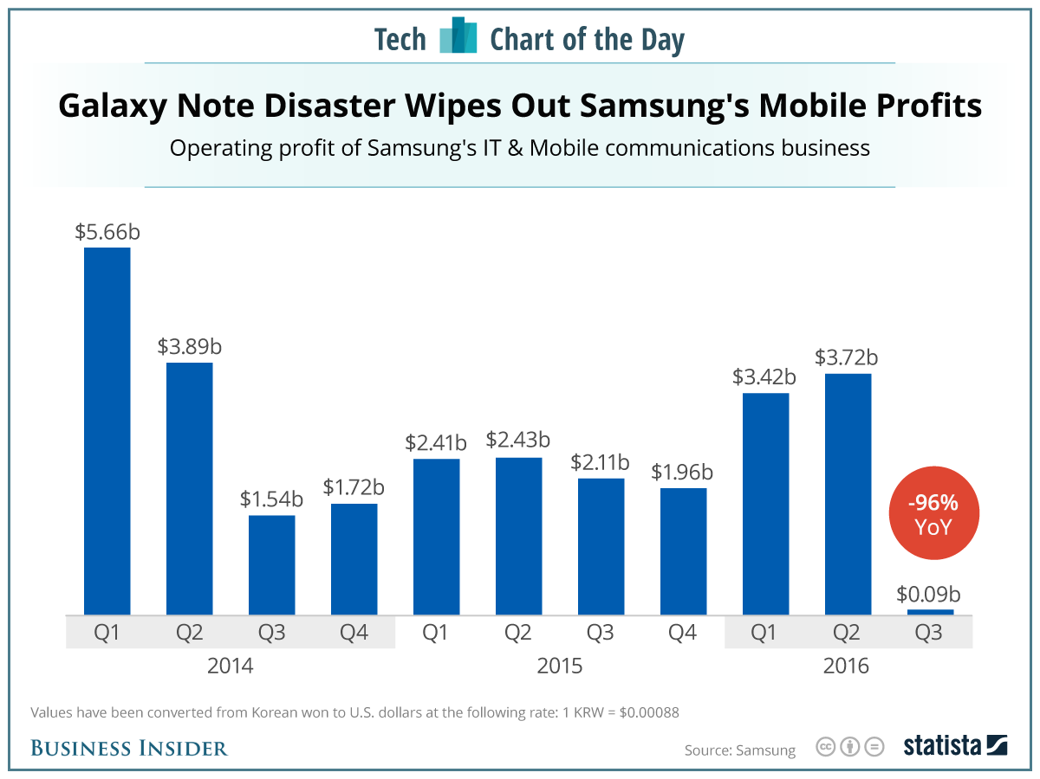

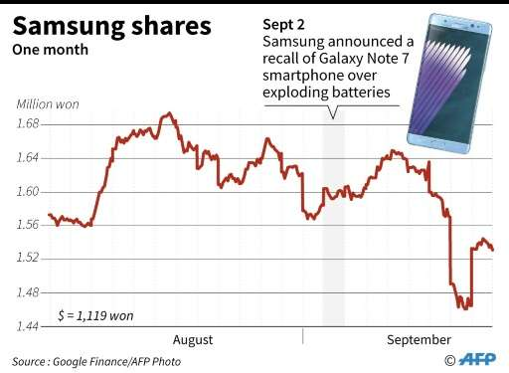

3.2 Stakeholder Reaction
The views of the key Stakeholders that would be interested in the decision should be analysed. So a Stakeholder analysis can be done using the Power/Interest Matrix and/or Position/Importance Matrix. See below. Plot stakeholder on the matrix.

Need to discuss the reaction of each of the stakeholder to the decision.
Example: Customers Reaction
A global recall of fire-prone Galaxy Note 7 smartphones did not appear to hurt U.S. consumers’ willingness to buy Samsung Electronics phones, a Reuters/Ipsos opinion poll Reuters (2016). The poll found that Samsung’s customers were fiercely loyal to their brand. Some 91% of current Samsung users would likely purchase another Samsung smartphone, and 92% of current users would probably buy another Samsung product in general Reuters (2016). Jackdaw Research (2016) said the recall was mostly limited to early adopters rather than the majority of Samsung’s customer base, which limited negative user experiences.

4.0 Implementation

Give intro into implementation plans i.e. what it includes (theory)

4.1 Deployment

Discuss how and what actions or tasks were required to implement the chosen solution (theory) and what actions were actually taken by the company?

4.2 Change management

Discuss the stakeholders likely to resist the action arising from the decision, explain how resistance was actually managed, how it should have been managed (theory), communication plan could be developed.

4.3 Project Management Issues

Develop a Risk Plan- use a table.

Discuss the key timelines used by the organization

Discuss the Cost/budget for implementing the decision

5.0 Conclusion
Summary of key findings and recommendations from above sections.

